|  |
| --- |
| KP GAMES |
| 2D - Shooter |
| Document |
| Version #1.0  All work Copyright © 2016 by KP Games.  All rights reserved. |
| **KHILAN PATEL - 300785048** |
|  |

|  |
| --- |
| February 16th 2016 |

Table of Contents

1. Game Overview 4

2. Game Play Mechanics 4

3. Camera 4

4. Controls 4

5. Interface Sketch 4

6. Menu and Screen Descriptions 5

7. Game World 5

8. Characters 5

9. Enemies 5

10. Scoring 5

11. Sound Index 6

12. Future Features 6

Version History

* Version 1.0: Initial Commit (Feb 2, 2016)
* Version 1.1: Added the Sprites in GUI (Feb 2, 2016)
* Version 1.2: Make perfect GUI (Feb 2, 2016)
* Version 1.3: Add the scripts (Feb 4, 2016)
* Version 1.4: GUI with the sound (Feb 4, 2016)
* Version 1.5: Fix Bugs (Feb 4, 2016)
* Version 1.6: Fully Functional Game (Feb 5, 2016)

1. **Game Overview**

*This game is about fighter plane on a quest of finding precious gems of galaxy. The player will get points based on the collecting gems. Player has to avoid the enemy planes in order to survive.*

1. **Game Play Mechanics**

*Player will get 100 points for 1 gems. If player will get more than 500 points then at the end of the game player will rewarded with the “happy smiley” and if not then player can see the “sad smiley”. Player has 5 chances to get survive. If player crash with the enemy plane then the lives will reduce. When player losses 5 lives, game will over and player will be asked to restart the game.*

1. **Camera**

*The point of view is user’s sight, this is in front of the scene*

1. **Controls**

*Player can use WASD and standard arrow keys to move.*

1. **Interface Sketch**

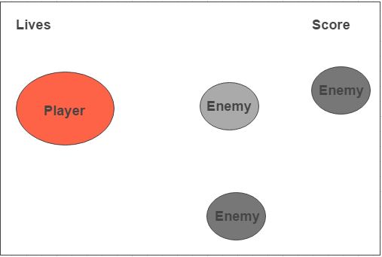

1. **Menu and Screen Descriptions**

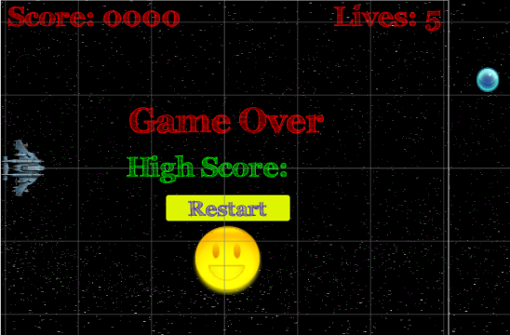

*Screen of the game shows the Scoreboard and Lives board. After end of the game it will display the High Score and Restart button to restart the game.*

1. **Game World**

*Game world is about the galaxy where Fighter plane is flying.*

1. **Characters**

*There are no such characters except the main player (Fighter Plane).*

1. **Enemies**

*There are other planes which hinder the player quest are enemies and cause damage.*

1. **Scoring**

*When player get one gems then player will get 100 points and when player crash will enemy then player loss 1 live.*

1. **Sound Index**

*The games has following sounds.*

*Engine – Sound of Fighter Plane*

*Crash – When Fighter Plane crash with enemy*

*Ting – When Fighter Plane get the gems.*

1. **Future Features**

*The Future features may include:*

1. *Weapons*
2. *Explosion*
3. *Levels*
4. *Boss of enemy*
5. *Power booster*